

**Recep Tayyip Erdogan University**

**Faculty of Engineering and Architecture**

**Computer Engineering**

CE103- Algorithms and Programming I

**Homework-2 (Week-4)**

**Fall Semester, 2020-2021**

| Instructor | Asst. Prof. Dr. Uğur CORUH |
| --- | --- |
| Contact Information | [ugur.coruh@erdogan.edu.tr](mailto:ugur.coruh@erdogan.edu.tr) |
| Google Classroom Code | **ouw44uk** |
| Publish Date | **04.11.2020** |
| Due Date | **13.11.2020 17:00** |

**Complete the following homework requirements, prepare them in the format given in the link below until the deadline and time, and upload them to the related assignment in the classroom.**

<https://drive.google.com/file/d/1yqSXZZ3346iIqotb_e_yzaryfxEXE0fR/view?usp=sharing>

**Grades:**

| Problem-1 | 40 points |
| --- | --- |
| Problem-2 | 60 points |
| **Total** | **100** points |

*You will develop the following examples in C language. The examples with C ++ will not be accepted.*

NOTE: In the code, add the following information with printf. Put the description of each application in the problem part.

*int main(void)*

*{*

*printf("Build Time: %s %s\n", __DATE__, __TIME__);*

*printf("Owner: Name Surname\n");*

*printf("Student ID: 11111111\n");*

*printf("Course: CE-103\n");*

*printf("Homework: 1\n");*

*printf("Problem: “Printing the Text Entered on the Screen in Reverse \n");*

*... your codes...*

*}*

**Problem-1**: *Convert Number to Strings (40 points)*

In this application you will develop a C program that converts console numeric inputs to string.

Your application must support the range between *999.999.999 and 0 (999.999.999>n>0)*

*Sample Output*

Build Time: Oct 28 2020 01:55:02

Owner: Name Surname

Student Number: 11111111

Course: CE-103

Enter Number to Spell: Input [No More Than 9 Digit]: '999999999'

Spelling:

nine hundred ninety nine million nine hundred ninety nine thousand nine hundred ninety nine

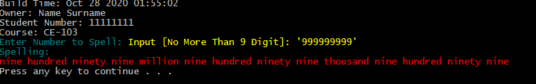

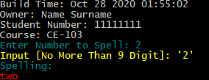

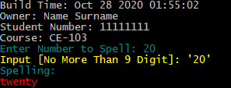

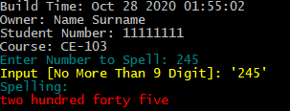

**Problem-2**: *Just Run and Try to Understand Examples (60 points)*

In the following portal <https://www.programiz.com/c-programming/examples> compile and run applications and write comments for codes to describe operations. In this problem you will compile and run examples between 1 and 54. You will share code with comments and your application screenshot in the report. Also you will share archive file of your all source codes.

